# View PDF Android widget

## Overview

For android hybrid apps there is no way to view pdf files in the webView, because the webView doesn’t currently support pdf files. This means that we couldn’t use the Cordova InAppBrowser plugin for viewing pdf files.

The solution we chose is to download the pdf file from the server and open the file with the default native pdf viewer application of the android device.

The pdf is saved to a temporary location on the android device.

This implementation uses a custom Cordova plugin that has to be configured in the Developer IDE.

## Configuring the custom Cordova plugin

This widget requires the custom Cordova plugin openFileInExternalViewer.

The plugin is embedded in the product widget, at the location IDE/widgets/com.temenos.widgets.hybrid.viewPDFAndroid/cordovaPlugin/openFileInExternalViewer.

You can also copy the plugin into your project, for example into $$PROJECT_HOME$/cordovaPlugins, and import it from there.

The Cordova plugins are configured from Developer IDE, menu Project->Properties, tab “Additional Cordova Plugins”:

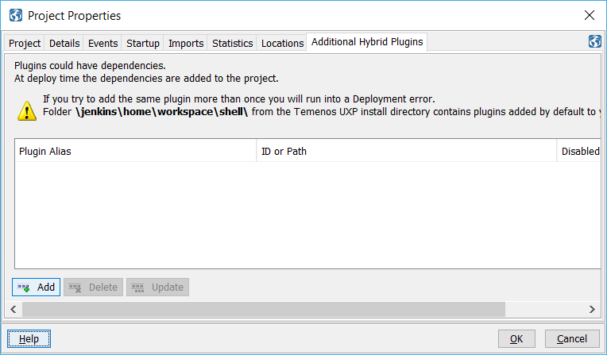

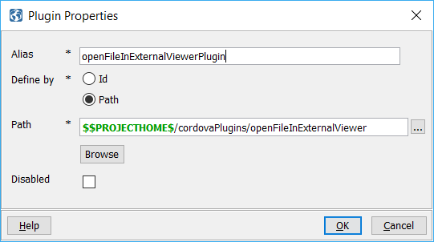

## Installation

1. Distributed with the product, so no special installation requirements.

## How to use

1. You will have to insert a new display Item of **“View PDF Android (Cordova Hybrid”)** type in the **Presentation Editor**
2. Within Widget Details tab you have to set up the widget settings:

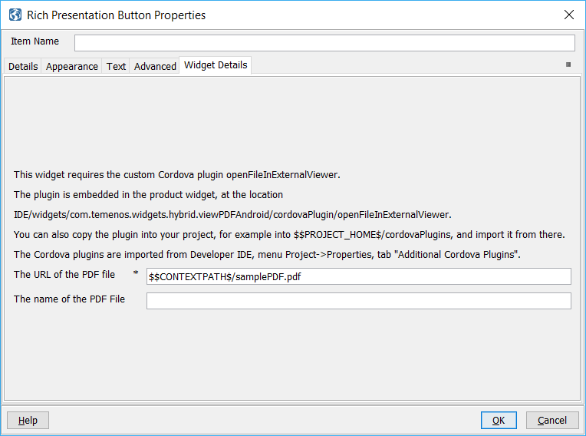

* **The URL of the PDF file**- Absolute or relative URL to the pdf file.
* **The URL of the PDF file** - Optional - you can specify the name for the PDF file when it is saved to the temporary storage on android. If you leave this blank, the name of the PDF file will be the last part of the URL of the PDF file.